**Assignment 15.1**

1. Write a simple program to show Inheritance in scala

**Sol:**

A child (or derived) class can have one and only one parent (or base) class.  
  “extends” keyword should be used when a child class inherits a parent class.

Example:

Lets create a Parent class called Version.

Now, lets create Child class Version2 that inherit the Version class.

We can override method A() accordingly.

Now, inside the main method, we create a Version2 object and we then access the method A() defined inside Version class.

Output:

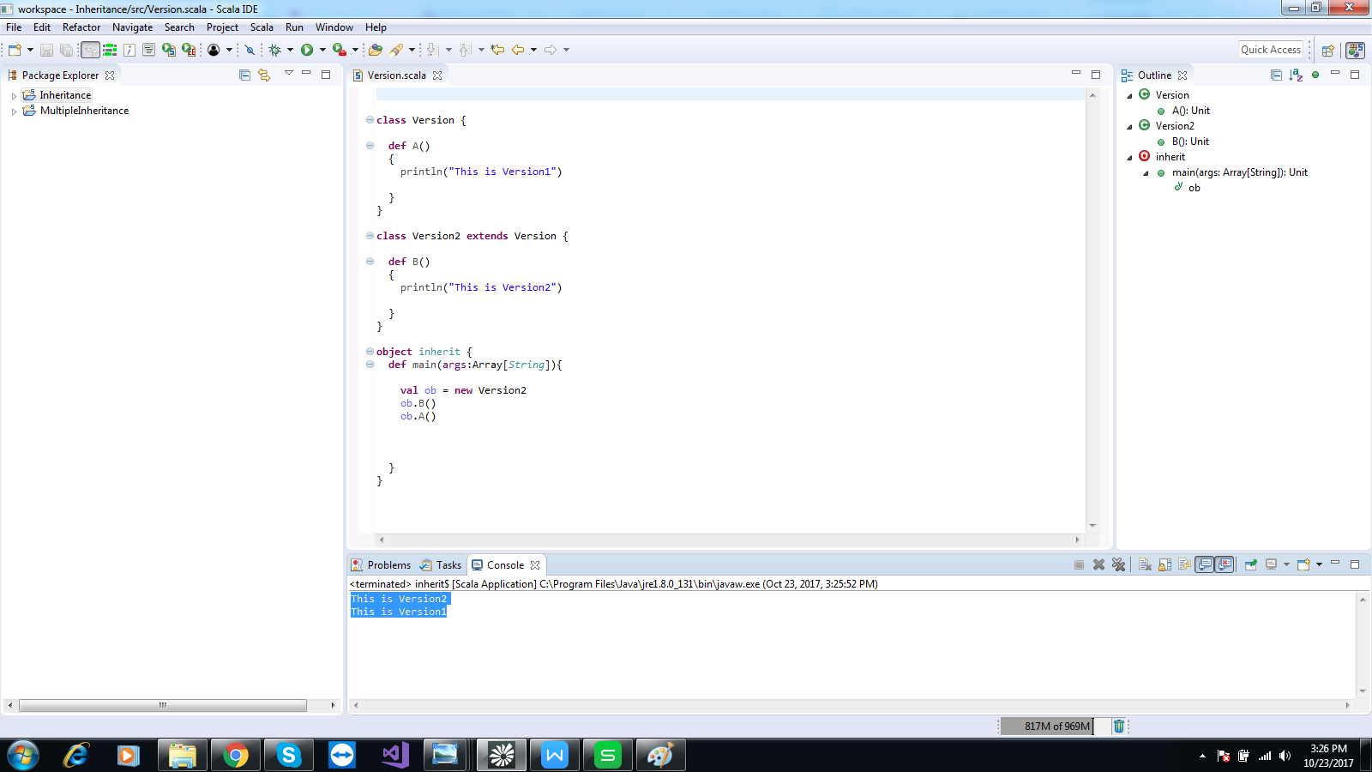

1. Write a simple program to show Multiple Inheritance in scala

Sol:

Java does not support multiple inheritance. Scala is different . It usages scala traits and mixin concept to implement multiple inheritance

Example:

Create trait One as parent and trait two and three as child traits which overrides the function defined in trait one

Class four is having 2 traits .2 traits having Same name Function

If we call the fun show () on the object of class four,it will call the fun in class written in the extreme right of it.

**Output:**

